**Long-Region Hypo-methylation in HBV Integration Regions Enhance HCC Non-invasive Surveillance by Low-pass Whole Genome-wide Bisulfite Sequencing.**

Haikun Zhang1,8, #, Peiling Dong2, #, Shicheng Guo3, #, Chengcheng Tao1, Wenmin Zhao2, Jiakang Wang4, Ramsey Cheung5, Augusto Villanueva6, Huiguo Ding2, Steven J. Schrodi3,7,*, Dake Zhang1,*, Changqing Zeng1,*

1Key Laboratory of Genomic and Precision Medicine, Beijing Institute of Genomics, Chinese Academy of Sciences, Beijing, 100101, China

2Department of Hepatology, Beijing You’an Hospital Affiliated with Capital Medical University, Beijing 100069, China

3Center for Precision Medicine Research, Marshfield Clinic Research Institute, Marshfield, WI, USA

4Biology Department, Stonybrook University, Stonybrook, NY, USA

5 Department of Gastroenterology and Hepatology, VA Palo Alto Health Care System and Stanford University, Palo Alto, CA, USA

6Liver Cancer Research Program, Division of Liver Diseases, Tisch Cancer Institute, Department of Medicine, Icahn School of Medicine at Mount Sinai, New York, NY, USA

7Computation and Informatics in Biology and Medicine, University of Wisconsin-Madison, Madison, WI, USA

8University of Chinese Academy of Sciences, Beijing 100049, China

# These authors contributed equally to this work

* Corresponding Author

## Abstract

Circulating cell-free DNA (cfDNA) methylation has been demonstrated to be a promising approach for non-invasive cancer diagnosis. However, the low-level of cfDNA and high cost of whole genome bisulfite sequencing (WGBS) significantly hinders the clinical implementation of a methylation-based cfDNA early detection biomarker. Here we proposed a novel method where we utilized long-region hypo-methylation (LRM) in low-pass WGBS data (<5-million reads) generated from cfDNA to detect methylation changes that could be used for early cancer detection. We applied low-pass WGBS to investigate dynamic changes in DNA methylation from blood samples of patients with hepatitis, cirrhosis, early and advanced hepatocellular carcinoma (HCC). We found a significant enrichment of differential methylation loci in intergenic and repeat regions, especially in HBV integration sites. Moreover, methylation profiles nearby HBV integration sites were found to enhance the prediction performance. The results demonstrate that low-pass cfDNA WGBS could be used as a low-cost and minimaly invasive approach for early HCC detection in the context of surveillance programs.

## Introduction

Circulating cell-free DNA (cfDNA) are small double-stranded DNA fragments(1) found in plasma, urine, and other body fluids(2) originating from cell apoptosis and necrosis(3). In many settings, analyses of cfDNA can be regarded as a way to perform a “liquid biopsy”, which have been shown promising results for early cancer detection(4, 5) and prognosis prediction(6, 7). Apoptotic and necrotic tumor cells can release cfDNA into the peripheral blood, which reflects tumor-related genetic features, including mutations, copy number aberrations and epigenetic changes(6). Meanwhile, cfDNA also carries tissues-specific information which provides promising abilities for tissue-of-origin maping(8-11). n importantThere are different technologies to interrogate methylation changes in cfDNA, including scRRBS(8) and cfMeDIPseq(11). However, genome-wide methylation assays require large amounts of input DNA—conventional WGBS requires microgram input and reduced respresentation bisulfite sequencing (RRBS) requires 30ng of DNA input which is often approaching the maximum level of the cfDNA detected (or detectable) in a human blood sample.

Liver cancer is the fourth cause of cancer-related mortality worldwide. In the United States, liver cancer death rate increased 43% from 7.2 to 10.3 per 100,000 between 2000-2016(12, 13). Hepatocellular carcinoma (HCC), the most frequent form of primary liver cancer, generally develops in patients with chronic liver disease due to hepatitis B virus (HBV), hepatitis C virus (HCV), alcohol abuse or non-alcoholic fatty liver disease(14, 15). Chronic inflammation, fibrosis, and aberrant hepatocyte regeneration favor a series of genetic and epigenetic events that culminate in hepatocyte malignant transformation. Hepatocarcinogenesis is a complex and poorly-understood multistep process that includes the histological transition from regenerative nodules in the context of cirrhosis, through dysplastic nodules and ultimately HCC (16-18). The high risk of HCC development in patients with cirrhosis (i.e., 2-4% annual risk) justifies the recommendation of biannual HCC surveillance with abdominal ultrasound (US) with or without serum alpha-fetoprotein (AFP) in patients at high-risk(19). Non-randomized studies suggest that early HCC detection increases the odds to receive a curative treatment and increase survival. However, the sensitivity of US and AFP is 63% to detect early stage HCC, which underscores the need for improved early detection tools. A number of studies have focused on cfDNA as a potential source of novel early detection biomarkers in HCC. This includes mutation profiling (20, 21), circulating tumor cells (CTCs)(22) and DNA methylation(23-28). As opposed to mutations and CTCs, DNA methylation analysis of cfDNA has the theoretical advantage of providing tissue of origin information, which is critical when cfDNA originates from a composite of cell types. Multiple studies have focused on the use of cfDNA methylation in cancer diagnosis in the areas of specific biomarkers (24, 28), pervasive hypo-methylation (23) and tissue of origin (25-27). Single cytosine measurement and high accuracy facilitate whole genome bisulfite sequencing (WGBS) to become the gold standard in DNA methylation analysis(29). One of the limitations of using WGBS for DNA methylation analyses on cfDNA is the need for deep sequencing (25, 27) which currently limits the wide-scale implementation in a clinical setting. Low depth sequencing in high sample numbers is a cost-effective strategy for cohort studies.(30) Utilizing reduced sequencing volume, low-pass sequencing and correspondingly low sequencing cost will be crucial to facilitate an easier clinical deployment of DNA methylation-based surveillance tools.

In this study, we evaluated the performance of low-pass whole genome bisulfite sequencing (WGBS) in cfDNA methylation profiling to identify the lowest sequencing depth for long-range methylation measurements. Applying the approach to a set of patients with different liver diseases (i.e., chronic hepatitis, cirrhosis and HCC), low-pass WGBS at 5-millilion sequencing reads was able to detect the hypo-methylation profiles of plasma cfDNA to discriminate each clinical entity. Additionally, we further illustrate the efficient diagnostic performance of low-pass WGBS assessing the methylation status of HBV integration regions.

## Results

### Efficacy of a low pass sequencing strategy illustrated by re-sampling reads from cell-free WGBS data

In order to determine the impact of sequencing depth on methylation profiles in cell-free based WGBS data, we conducted a pilot study with 5 samples: one healthy individual (D1), one patient with chronic hepatitis (D2), one patient with cirrhosis (D3) and 2 HCC patients (D4 and D5 of before and after surgery). The final read count equated to a mean of 58 million (M) reads per sample (**Supplementary Table 1**). The average DNA methylation across the genome was much lower in the HCC patient (D4; 53.56%) compared to healthy individual, cirrhosis and chronic hepatitis(74.76%, 75.64% and 75.13%; **Supplementary Table 1**). We applied long range methylation (LRM) to measure the methylation status of cfDNA in these samples. To identify the optimal region size of LRM, we divided the HCC genome (D4) into 500-Kb, 1-Mb, 1.5-Mb, 2-Mb and 2.5-Mb bins, respectively. For each region size, we calculated the average methylation level within each window for the genome. Then the percentage of regions with hypo-methylation was calculated in the HCC sample (D4). We found when we use 2-Mb as the window size, the percentage of hypo-methylated regions in D4 have the maximum ratios (**Figure S1; Supplementary Table 1**). Finally, the LRM for all 1,382 autosomal 2-Mb regions were used for global methylation level calculation (**Materials and Methods**).

To determine the effective sequencing depth in low pass WGBS of cfDNA, we randomly sampled 1M to 10M mappable reads from each sequencing dataset (each composed of approximately 58M reads) and calculated the average methylation level for each 2-Mb region (MethylLRM). In each iteration, we calculated MethylLRM forall 2-Mb regions, and adopted correlation coefficient to show their consistency with those based on total sequencing reads. For each sequencing depth, we repeated the random extraction 100 times to examine the variation of the correlation coefficient, and the difference (coefficient of variation, CV) among 100 values of the correlation coefficient to assess sampling bias. We confirmed a high correlation between our low pass WGBS results as compared to all reads, with a CV below 4% in most of our samples (**Fig 1**). As predicted, when we increase the number of sequencing reads, MethylLRM was closer to the value calculated using total sequencing reads (**Fig 1**). The correlation coefficient between the methylation level from low-pass WGBS and the raw WGBS data saturates when using 5M or more reads. The correlation coefficient between MethylLRM at 5M reads and all sequencing reads was above 0.92 (Pearson’s correlation coefficient, P < 2.2x10-16, **Figure S2A-B**), and methylation level remained consistent after resampling 100-times (CV is 0.72%, 0.11%, 1.09%, 0.13%, 0.38% for D1, D2, D3, D4 and D5, respectively, **Fig 1**). In summary, we show how 5M mappable reads without redundancy in low pass WGBS is a reliable method to evaluate the methylation level of cfDNA samples in the long-range mode.

### Methylation level of plasma cfDNA from chronic hepatitis and cirrhosis patients resembles healthy individuals

We next sought to evaluate the ability of low pass WGBS of cfDNA to discriminate patients with different liver diseases. Thus, we conducted low pass WGBS in plasma cfDNA of 54 individuals, including 17 HCC (3 early stage HCC, 5 advanced HCC and 9 HCC patients after surgery, 16 were HBsAg positive and 1 was anti-HBs positive) , 17 with cirrhosis (14 from HBV, 1 from NASH, 1 from alcohol and 1 undetermined), 17 with hepatitis B and 3 healthy volunteers (**Supplementary Table 2**). On average, 10.2M mappable reads were obtained from each sample (IQR=6.3M, **Supplementary Table 3**). We conducted principal components analysis (PCA) to investigate the data structure of low-pass WGBS data across all of the samples. A significant separation between advanced HCC and the remaining samples was observed (**Figure S3**). To evaluate the predictive performance of classifying HCC from non-HCC, five-fold cross-validation was applied to a logistic regression model and random forest (RF) model, assessing the predictive accuracy from low-pass WGBS data. From the logistic regression model, the sensitivity, specificity and accuracy to detect HCC in the training set were 65.0%, 98.7%, and 94.2%, respectively. For the test set, these metrics were estimated to be 71.2%, 98.0% and 91.4%, respectively. With the RF algorithm, the averaged out-of-bag prediction accuracy was 92.2%. Applying a five-fold cross-validation and using 100 random resampling iterations on the RF model, the average sensitivity, specificity and accuracy were found to be 62.5%, 97.6% and 91.1%, respectively. These data were also subjected to a neural network classifier using the top 10 features selected by the RF approach using the training set. The neural network prediction in the test set attained an AUC=0.90 (**Figure S4**).

To evaluate the methylation levels in these samples, we applied the LRM strategy to define the hyper- or hypo-methylated LRM regions (**Materials and Methods**), using MethylLRM in healthy individuals as the baseline level. The percentage of hyper- or hypo-methylated LRM regions is shown for each patient (**Fig 2; Supplementary Table 3**). In hepatitis and cirrhosis patients, we found that hyper-long methylated regions (hyper-LMRs) accounted for <3% of total 1382 autosomal LMRs (**Fig 2A**), while hypo-long methylated regions (hypo-LMRs) accounted for 0.0-20.04% of the total LMRs, with only three patients exceeding 10% (**Fig 2B; Supplementary Table 3**). This data suggest that patients with hepatitis and cirrhosis have similar cfDNA methylation levels with healthy individuals (**Fig 2**). Further, in early stage HCC patients, no hyper-LMR were identified, however hypo-LMRs accounted for 1.2% to 26.2% of the total LMRs. In advanced HCC patients, no hyper-LMR were identified, and hypo-LMR accounted for more than 65.7% of the total LMRs (**Fig 2; Supplementary Table 3**). As expected, after surgery, most HCC patients (8/9) demonstrated similar cfDNA methylation levels to healthy individuals and patients with hepatitis or cirrhosis. Nevertheless, one (P45) out of the nine HCC patients exhibited a higher proportion of hypo-LMRs after surgery (69.9%, **Fig 2B**; **Supplementary Table 3**), and died two months later due to tumor recurrence, suggesting that there were micro-metastasis with tumor cells in that individual. We find a significant positive relationship between AFP and the percentage of hypo-LMRs (R=0.6, P=3.9x10-6, Pearson’s correlation coefficient). We also evaluated the diagnostic potential of low-pass WGBS data to HCC and we found the percentage of hypo-LMRs showed better diagnosis performance than AFP (AUC= 0.966 vs 0.826; **Figure S5**). Our results demonstrate that LMR could serve as a early HCC detection biomarker as it reflects genome-wide demethylation changes from non-tumoral tissues to HCC. It could also be used as a method to detect minimal tumoral residual disease after surgical resection.

### Differentially methylated CpGs (DMCs) and genes (DMGs) identified by low-pass cell-free WGBS

We identified DMCs and DMGs with low-pass cell-free WGBS data, and very limited CpGs were covered by our assay. On average, each cfDNA sample had 61,018 CpGs with sequencing depth over 5 reads (**Method, Supplementary Table 3**). In total, advanced HCC patients had 1,695 DMCsidentified (**Supplementary Table 4**), of which all the DMCs were hypo-methylated compared to healthy individuals. Among those, 23 DMCs were located in seven genes: *HFM1, PMF1, PMF1-BGLAP, SENP5, SLCO5A1, REXO1L1P, DLG2*. In the one early stage HCC patients (percentage of hypo-LRMs=26.27%), we identified 249 DMCs (**Supplementary Table 5**), of which 207 were in common with those observed in advanced HCC patients and nine were located within *PMF1* and *PMF1-BGLAP*. Relatively high proportions of hypo-LMRs (>10%) were observed in one chronic hepatitis and two cirrhosis patients (**Fig 2B**), possibly indicating their high HCC risk. In total, all four clinical groups had 165 DMCs in common (**Fig 3A**), which suggested that DNA methylation changes may occur in the early stages of liver disease progression prior to HCC. **Fig 3A** displayed the genes with DMCs in four comparisons. Moreover, 31 DMCs were identified between early stage HCC (**Supplementary Table 8**) and cirrhosis patients and 1,305 DMCs were identified between advanced HCC and early stage HCC patients (**Supplementary Table 9**), with no overlap detected between the two compatisions. In particular, *SENP5* gene had seven significantly hypo-methylated DMCs with consistently high sequencing coverage across all individuals (149 reads, on average, **Figure S6**, and **Fig 3B**). Intriguingly, all 7 DMCs that we found in intron 2 of *SENP5* were located near previously reported HBV integration sites in HCC (**Fig 3C**) (31).

### Overrepresentation of DMCs in repeat regions and surrounding HBV integration sites

The distribution of CpGs tended to be located at intergenic and repeat regions (**Methods, Figure S7A**). Also, CpGs in repeat regions had much higher sequencing depth in this low pass sequencing strategy compared to those in other regions (P < 2.2x10-16, Wilcoxon rank sum test; **Figure S7B**). On average, 64% of all these CpGs were in the repeat regions (**Figure S7C**), and this percentage varied from 49% to 87% across the samples. Differential methylation analysis required the CpG sites having at least five sequencing reads in all samples (**Method**), and the resulting CpGs were over represented in repeat regions. Finally, 91% of DMCs of advanced HCC patients were located within repeat regions (**Fig 4A**). Considering that repeat regions are a known target for HBV integration (32, 33), we analyzed the location of DMCs relative to reported HBV integration sites (31, 34-39). Among the 1,695 DMCs observed in advanced HCC patients, eighteen completely overlapped with the HBV integration sites, including two in *SENP5* (**Supplementary Table 8**). Additionally, 36.5% of the DMCs were located within a 100bp region either upstream or downstream of integration sites, and 95.8% of DMCs were within 5Kbp (**Fig 4A**). Overall, these DMCs were more enriched in HBV integration sites compared to promoter and gene coding regions (**Fig 4B**).

In order to evaluate whether methylation levels of CpGs near HBV integration sites could mirror the hypo-methylation profiles of cfDNA from HCC patients, CpGs with read depth exceeding 5 reads were analyzed in all 54 samples within 100bp flanking HBV integration sites and calculated the percentage of hypomethylated CpGs. These CpGs were found to be significantly hypo-methylated in advanced HCC patients, with 9.6% to 59.1% of CpGs being hypo-DMCs, while the proportion was generally reduced (2.6-10.2%) in early stage HCC patients. (**Fig 4C; Supplementary Table 3**). Then, All CpGs from each sample was used to calculate the average methylation level of the CpGs within the 100bp of the reported HBV integration sites (MethylHBV**)**. The advanced HCC patients still showed significantly hypo-methylation level compared to healthy individuals (<66.5%; P = 0.03, Wilcoxon rank sum test; **Fig 4D**; **Supplementary Table 3)**. However, for early stage HCC patients, this methylation level was relatively higher, ranging from 67.2% to 71%. Additionally, a strong negative correlation was observed between MethylHBV and alpha-fetoprotein (AFP) levels (R = -0.63, P = 8.4x10-7, Pearson’s correlation coefficient; **Fig 4D, Figure S8**).

To further assess the diagnostic accuracy of MethylHBV in HCC patients, a receiver operating characteristic (ROC) curve analysis based on logistic regression was conducted for 37 individuals without HCC (3 healthy individuals, 17 patients with cirrhosis and 17 patients with hepatitis) and 8 HCC patients (3 early stage HCC and 5 advanced HCC), and AUC was 0.93 (95% CI: 0.84-1.00). The sensitivity and specificity of the prediction were 97.29% and 75% when MethylHBV was 67.28% as the optimal cutoff point for tumor detection. Moreover, four patients with chronic hepatitis or cirrhosis (P2, P14, P18, P19) exhibited MethylHBV levels that approached the cutoff value (**Fig 4D, Table 1)**. One chronic hepatitis patient, P14, had the average methylation level at 67.4% and abnormal AFP level (141.9 ng/ml; **Table 2**). Its blood sample was temopariligy labeled as chronic hepatitis since he was a follow-up patient with chronic HBV infection; however, he was diagnosed as HCC in this examination and died 8 month later. Therefore, he was likely to has circulating tumor cell at the time since his AFP was significantly elevated. For patient P2 (chronic hepatitis) and P18 (NASH-related cirrhosis) both had no observed abnormal measurements and have not had a detected tumor. The AUC result showed that the MethylHBV had the best diagnosis performance (AUC=0.977; **Figure S5**) with or without AFP levels in the model. Our results indicate hypo-methylation in HBV integration regions could be a potential biomarker to evaluate the risk of the transformation from hepatitis and cirrhosis to HCC in patients with chronic hepatitis B infection.

## Discussion

Patients with chronic liver disease are at high risk of HCC development. Professional societies recommend HCC surveillance in those patients at high risk who will benefit from and early diagnosis and application of curative therapies. The recommended strategy for surveillance includes abdominal ultrasound with or without alpha-fetoprotein (AFP) every 6 months. However, image examination needs huge amount of medical rescource, including instruments and professional personnel, especially considering the large population of patients with HBV infection in China. Addtionally, patients are reluctant to take image examination due to time consuming and cost consideration. Therefore, there is an unmet clinical need for new non-invasive diagnostic tests, such as liquid biopsy using circulating tumor cells (40). Unfortunately, The European Association for the Study of the Liver did not recommend the use of any tumor marker including AFP for HCC surveillance, and in the prior version of the American Association for the Liver Diseases, AFP was felt to lack both sensitivity or specificity for early detection of HCC Subjects at highest risk for HCC are those with chronic hepatitis and advanced fibrosis, and hepatic inflammation can result in elevation of AFP, and some HCC was non-AFP producing. Current study found a strong negative correlation between MethylHBV and AFP levels. However, unlike AFP, the MethylHBV level was not affected by the presence of inflammation, hence making it a more specific tumor marker..Nevertheless, we (40)believe future comparision between these biomarkers and ultrasound detection deserves extensive investigaton. Although WGBS of cfDNA has been shown effective for cancer detection (26), the cost of cfDNA WGBS in cancer patients is one of challenges for wide application. We explored the cfDNA methylome of hepatitis, cirrhosis and HCC patients and examined the feasibility of HCC detection using low-pass WGBS. We demonstrated the measurement of long-range methylation could be applied in low-pass cell-free WGBS at 5-million reads to reflect liver disease status of chronic hepatitis, cirrhosis and HCC. Moreover, DNA hypomethylation in HBV integration regions was shown promising results as a potential biomarker for early detection.

Previous reports applying genome-wide hypomethylation in HCC detection and shown low sequencing depth of ~10 million reads was available for the cell-free detection for cancer (23). In our study, we required only 5M qualified reads for low-pass WGBS for 54 samples, and there were 2 samples only having 3.6M reads (**Supplementary Table 3**). In a 100-iteration resampling procedure, the average correlation coefficient was larger than 0.9 using 3M reads (**Fig 1**)—theoretically sufficient to evaluate methylation levels. This indicates that sequencing depth could be decreased to ~3 million reads with long-range DNA methylation measurements without substantially compromising accuracy. In our analysis based on limited sample size, all five advanced HCC patients were detected according to this measurement. But for patients with early stage HCC, the sensitivity of our DNA methylation approach in plasma is lower. Specifically, P35 and P36, both the proportion of hypo-LMRs (1.23% and 4.7%) and the average methylation level around HBV integration sites (70.48% and 71.48%) were similar to the healthy individuals and chronic hepatitis patients. Both of these two patients had small tumor sizes (P35, 1.5cm; P36, less than 2cm, three lesions; **Supplementary Table 2**).

Previous studies have been shown that the fragmentation process of cfDNA is not random (41, 42). Our results show low-pass WGBS for cfDNA tended to capture fragments from repeat regions and HBV integration sites. More than 49% of CpGs were located in the repeat regions and had a higher sequencing depth. When decreasing the sequencing volume, overrepresentation of genomic repeat regions was observed in our data. This suggests that the signal from repeat regions could remain given adequate sequencing depth in low pass WGBS. Since HBV integrations tend to localize at repeat regions, DMCs of advanced HCC patients were also enriched in previously reported HBV integration sites.

We adopted an approach focusing on 100bp upstream and downstream regions from HBV integration sites as surrogate regions for plasma hypomethylation analysis in HCC patients. Although we chose HBV integration sites as the indicator, it does not necessarily indicate that the analysis is only suitable for patients with HBV infection. In our sample set, we also included 3 patients without HBV infection (P1, P18 and P19; **Supplementary Table 2**). While HBV integrations carried by dominant tumor clones are likely to have some specific DNA molecular features, we also demonstrated that methylation changes in HBV integration regions may be common in HCC and independent of HBV infection. Interestingly, we found hypomethylation in HBV integration regions have higher sensitivity for HCC diagnosis. For example, except P14 (chronic hepatitis), the sample from a chronic hepatitis patient, P2, showed that the proportion of LMRs was 17.8% and the average methylation level around HBV integration sites was 67.7%. Using the sample from a clinical visit 6 months following the initial sample collection, the proportion of LMRs dropped to 1.1%, whereas the average methylation around HBV integration sites slightly increased to 69%. This patient had no detected HCC in follow-up, showing that MethylHBV is more stable than genome-wide LMR. As a predictor of HCC, the most challenging aspect is to determine appropriate cutoffs for disease status, which necessitates large sample sizes in future studies. Nevertheless, our study successfully illustrated that it is necessary to monitor the patients with suspicious methylation changes in cfDNA according to multiple indicators, combining their prognostic signals to improve accuracy.

Although we have found some stable methylation patterns using low-pass WGBS, we still need to validate these findings in larger studies. The low-coverage caused by the low-pass WGBS sequencing provided difficulties in deep-analysis to biology question, however, we found it is valuable for clinical implementation. Our studies can be used to further develop these approaches and improve the accuracy of HCC diagnoses and surveillance. Larger studies will enable the determination of accurate cutoff values for disease stages, especially for those with small tumors. Furthermore, we anticipate that blood samples from HCC patients at multiple time points hold strong utility in tracking disease progression.

## Materials and Methods

### Sample collection

All the blood samples of patients were collected from Beijing You’an Hospital. Healthy individuals enrolled by Beijing Institute of Genomics were collected as controls. The diagnosis was made according to the guidelines for the prevention and treatment of chronic hepatitis B: a 2015 update (43). We collected age, gender, HBV-status, tumor size and Alanine aminotransferase (ALT) test, Aspartate aminotransferase (AST) test, bilirubin test, Alpha-fetoprotein (AFP) test and other related clinical information for related samples. Meanwhile, HCC patients were classified as early and late stage according to the BCLC system. The study protocol conformed to the ethical guidelines of the 1975 Declaration of Helsinki and was approved by the Ethics Committee of Beijing You’an Hospital and Beijing Institute of Genomics. An informed consent was obtained from all patients and volunteers.

### Cell free DNA extraction

Ten microliters (ml) of whole blood was collected from each patient in Streck Cell-Free DNA BCT® tubes (Streck, Omaha, NE) and immediately shipped to Beijing Institute of Genomics. Upon arrival, the blood was collected in Streck BCT tubes were centrifuged at 3,000 × g for 15 minutes at 4°C within two hours. Subsequently, the plasma was transferred into a fresh microcentrifuge tube, followed by a 2nd centrifugation at 16,000 × g for 10 minutes at room temperature. Five ml of resultant plasma was used for cfDNA extraction using a QIAamp Circulating Nucleic Acid Kit (Qiagen, Valencia, CA). After extraction, total DNA was quantified using a Qubit dsDNAHS Assay kit (Life technologies, Grand Island, NY, USA). All DNA samples were stored at -80°C before sequencing library construction.

### Whole genome bisulfite sequencing and data processing

Using the TruSeq DNA Methylation Kit (Illumina Inc.) according to the manufacturers’ protocol. Total cfDNA (range from 0.5 ng to 88.7 ng) was used for sequencing library construction. Bisulfite conversion of cfDNA was performed using the EZ DNA Methylation-Gold Kit (Zymo Research) according to the instruction manual. During conversion, 0.5% methylated lambda DNA was included as a spike-in DNA control to estimate the conversion efficiency of unmodified cytosine. The sequencing libraries were then performed paired-end sequencing (2 × 100 bp) on an Illumina HiSeq 4000 (Illumina Inc., San Diego, CA, USA). The raw sequence data reported in this paper have been deposited in the Genome Sequence Archive (44) in BIG Data Center (45), Beijing Institute of Genomics (BIG), Chinese Academy of Sciences, under accession numbers CRA001537, CRA001537 that are publicly accessible at <http://bigd.big.ac.cn/gsa>.

After base calling, all paired-end fastq files were trimmed using cutadapt (v 1.8.3)(46) to removed adapter sequences and low quality bases with parameters ‘-q 15 --minimum-length 36’. HG19 reference genome was downloaded from ENSEMBL. Lambda genome was also included in the reference sequence for calculating bisulfite conversion rate. Filtered paired-end bisulfite sequencing data were mapped with Bismark (v0.14.5)(47) using with default parameters. After alignment, read duplicates were removed using the deduplicate_bismark application included in the bismark software. Then the BAM files produced by Bismark were sorted using samtools (v 0.1.19) and overlapping paired-end reads were clipped using ClipOverlap function of bamUtil (<https://github.com/statgen/bamUtil>) to prevent counting twice from the same observation. For each CpG, the methylation level was combined from both DNA strands and estimated as m/(m + u), where m was defined as the number of methylated cytosines and u was defined as the number of unmethylated cytosines. The number of methylated and unmethylated cytosines of long range regions were generated using R package methylKit. The average methylation level of each long range region (MethylLRM) was calculated as the total number of cytosines divided by the number of methylated cytosines.

### Identification of the optimal region size of long range methylation (LRM)

The HCC genome was divided into 500-Kb, 1-Mb, 1.5Mb, 2-Mb and 2.5-Mb segments. For each size, the average methylation level for each region from autosome was calculated. The hypo-methylated region were identified as methylation level difference larger than 0.2 compared to the corresponding region in heathy individual. Then the percentage of hypo-methylated regions across the genome was calculated. The largest percentage of hypo-methylated region size was selected as the optimal size of LRM

### Randomly re-sampling lower reads from medium WGBS data

A random sampling method was used to obtain low depth WGBS for 5 medium WGBS of cell-free DNA: (a) 1M to 10M read pairs (increasing by 1M step) was randomly extracted from each medium WGBS data set. (b) For each resampling, the average methylation level for each autosomal 2-Mb region (MethylLRM) was calculated and a Pearson correlation coefficient was used to show the correlation for all the autosomal MethylLRM between the resampled reads and the total WGBS reads. This process was repeated 100 times. (c) For each resampling, a coefficient of variation (CV) for the correlation coefficient was calculated across the 100 random resamples to examine the variability of the 100 extractions.

### Identification of hyper-LRMs and hypo-LRMs

We adopted the method of Chan et al.(23) to define the hyper- or hypo- MethylLRM compared to the healthy reference group. Only autosomes were included in this analysis. A 2-Mb region from a sample was defined as hyper- or hypo-methylated if its average methylation level was at least 3 SDs above or below the mean of the corresponding region within the healthy individuals. Lastly, the number and percentage of hyper- or hypo- MethylLRM within the genome were calculated.

### Identification and annotation of the differentially methylated CpGs (DMCs) and genes (DMGs)

The identification of DMCs was generated using the R package methylKit (48). The significance of the DMCs departure between two groups was calculated using a logistic regression test with at least 5-fold coverage. P-value was adjusted for multiple testing with the method of Benjamini and Hochberg (49). The CpG sites were considered different between cases and controls if the Benjamini-Hochberg corrected P-value ≤ 0.05 and the methylation level difference was ≥ 0.2. Each DMCs was annotated for each RefSeq transcript obtained from ENSEMBL GRCh37. Promoters are defined as regions 2kb upstream from TSS for each RefSeq transcript. RepeatMasker annotations were obtained from UCSC Genome Browser (50).

### The enrichment score in each genomic region

The enrichment score for CpGs or DMCs was calculated by the following formula:The enrichment scorein the genomic element = log2 (# DMCsin the genomic element/# expected). # expected was computed as: # DMCsin the genome × # CpG sitesin the genomic element/# total CpG sitesin the genome. # means the number of sites.

### DNA methylation of CpGs near the HBV integration sites in chronic hepatitis, cirrhosis and HCC

Identification of hypo-CpGs within the 100 bp upstream or downstream of HBV integration sites. The HBV integration sites were extracted from previous reports (31, 34-39).We extracted CpG within the 100bp upstream or downstream of HBV integration sites. Only autosomal CpGs and CpGs with depth over 5 reads in all the 54 samples were included in the hypo-CpGs analysis. Similar to the identification of hypo-LRMs, a CpG of a sample was defined as hypo-methylated if its methylation level was 3 SDs or more below the mean of the corresponding CpGs of the healthy individuals. Next, the percentage of hypo-CpGs was calculated. Average methylation level of the CpGs within the 100bp of the HBV integration sites was then determined. For each sample, the average methylation level of CpGs within the 100 bp upstream or downstream of HBV integration sites was included in all the CpGs. This value was calculated as the number of the total number of methylated cytosines divided by the number of total cytosines within the 100bp of the HBV integration sites.

### Prediction analysis, logistic regression, Random Forest and ROC curves

Five-fold cross-validation combined wrapped logistic regression were used to show the prediction performance for low-pass WGBS data. The detailed procedure is that DNA methylation data were divided into 5 equal parts and each of them was set as test dataset while the remaining as the training dataset. In the training stage, prediction model was fitted with feature selection by the Akaike information criterion (AIC) criteria with forward and backward selection. The detailed procedure is that we first starts with the full model and eliminates one predictor at a time, at each step considering whether AIC shows significant decrease by adding back in the variable removed at the previous step. Finally, we make the prediction with the prediction model built in training stage to test dataset and summarize the prediction sensitivity, specificity and accuracy. We also applied five-fold cross-validation based random forest to reduce bias of the prediction. Random Forest approach was conducted with R package randomForest. The neural network algorithm was based on the R package neuralnet.  Feature selection was conducted in the training set under 10-fold cross validation with the top features ranked using the MeanDecreaseGini function.  Model performance was then evaluated separately in the training and test sets. Analysis of receiver operating characteristics (ROC) curves was constructed using R package PredictABEL. The optimal cutoff was determined using the “coords" function from R package pROC (51). The optimal cut-off was the threshold that maximized the distance to the identity (diagonal) line.

**Acknowledgements**

This study is funded by Innovation Promotion Association CAS (2016098) and National Natural Science Foundation of China (81201700) to D.Z., Major State Basic Research Development Program (2014CB542006), the Key Research Program of the Chinese Academy of Sciences (KJZD-EW-L14) to C.Z., Capital's Funds for Health Improvement and Research (2018-1-1151) to P.D., and NLM training grant to the Computation and Informatics in Biology and Medicine Training Program (NLM 5T15LM007359) to S.G.

**Authorship Contributions**

HZ and SG performed analyses, developed analysis methods and power calculations, interpreted results, and drafted the manuscript. PD enrolled patients and collected all the clinical information. CT and JK conducted sequencing experiments. ZW collected and prepared tissue samples for sequencing analysis and collected results of clinical assays. RC and AV interpreted results, provided liver cancer and hepatology clinical expertise, reviewed and edited the manuscript. HD aided in the analyses and reviewed the manuscript. HD provided clinical advice and reviewed the manuscript. SJS provided analysis advice, aided in coordinating scientific activities, reviewed and edited the manuscript. DZ and CZ designed the study, supervised all experiments and analysis, provided molecular and cellular biology advice, reviewed and edited the manuscript.

**Disclosure of Conflicts of Interest**

The authors declare no conflict of interest.

**Abbreviations**

LRM Long-Region Methylation

HCC Hepatocellular Carcinoma

DMCs Differential Methylation CpGs

DMGs Differential Methylation Genes

HBV Hepatitis B virus

HCV Hepatitis C virus

GWBS Genome-wide Bisulfite Sequencing

RRBS [Reduced Representation Bisulfite Sequencing](https://en.wikipedia.org/wiki/Reduced_representation_bisulfite_sequencing)

cfDNA Circulating cell-free DNA

## Reference

1. Fleischhacker M, Schmidt B. Circulating nucleic acids (CNAs) and cancer - A survey. Biochimica Et Biophysica Acta-Reviews on Cancer 2007;1775:181-232.

2. Chan AK, Chiu RW, Lo YM, Clinical Sciences Reviews Committee of the Association of Clinical B. Cell-free nucleic acids in plasma, serum and urine: a new tool in molecular diagnosis. Ann Clin Biochem 2003;40:122-130.

3. Stroun M, Maurice P, Vasioukhin V, Lyautey J, Lederrey C, Lefort F, Rossier A, et al. The origin and mechanism of circulating DNA. Ann N Y Acad Sci 2000;906:161-168.

4. Corcoran RB, Chabner BA. Cell-free DNA Analysis in Cancer. N Engl J Med 2019;380:501-502.

5. Fiala C, Diamandis EP. Cell-free DNA Analysis in Cancer. N Engl J Med 2019;380:501.

6. Schwarzenbach H, Hoon DSB, Pantel K. Cell-free nucleic acids as biomarkers in cancer patients. Nature Reviews Cancer 2011;11:426-437.

7. Wan JCM, Massie C, Garcia-Corbacho J, Mouliere F, Brenton JD, Caldas C, Pacey S, et al. Liquid biopsies come of age: towards implementation of circulating tumour DNA. Nat Rev Cancer 2017;17:223-238.

8. Guo S, Diep D, Plongthongkum N, Fung HL, Zhang K, Zhang K. Identification of methylation haplotype blocks aids in deconvolution of heterogeneous tissue samples and tumor tissue-of-origin mapping from plasma DNA. Nat Genet 2017;49:635-642.

9. Moss J, Magenheim J, Neiman D, Zemmour H, Loyfer N, Korach A, Samet Y, et al. Comprehensive human cell-type methylation atlas reveals origins of circulating cell-free DNA in health and disease. Nat Commun 2018;9:5068.

10. Cristiano S, Leal A, Phallen J, Fiksel J, Adleff V, Bruhm DC, Jensen SO, et al. Genome-wide cell-free DNA fragmentation in patients with cancer. Nature 2019.

11. Shen SY, Singhania R, Fehringer G, Chakravarthy A, Roehrl MHA, Chadwick D, Zuzarte PC, et al. Sensitive tumour detection and classification using plasma cell-free DNA methylomes. Nature 2018;563:579-583.

12. JQ X. Trends in liver cancer mortality among adults aged 25 and over in the United States, 2000–2016. NCHS Data Brief, no 314 2018.

13. Villanueva A. Hepatocellular Carcinoma. N Engl J Med 2019;380:1450-1462.

14. Chen CJ, Yu MW, Liaw YF. Epidemiological characteristics and risk factors of hepatocellular carcinoma. J Gastroenterol Hepatol 1997;12:S294-308.

15. Montesano R, Hainaut P, Wild CP. Hepatocellular carcinoma: from gene to public health. J Natl Cancer Inst 1997;89:1844-1851.

16. Stauffer JK, Scarzello AJ, Jiang Q, Wiltrout RH. Chronic inflammation, immune escape, and oncogenesis in the liver: a unique neighborhood for novel intersections. Hepatology 2012;56:1567-1574.

17. Aihara T, Noguchi S, Sasaki Y, Nakano H, Imaoka S. Clonal analysis of regenerative nodules in hepatitis C virus-induced liver cirrhosis. Gastroenterology 1994;107:1805-1811.

18. Schutte K, Bornschein J, Malfertheiner P. Hepatocellular carcinoma--epidemiological trends and risk factors. Dig Dis 2009;27:80-92.

19. European Association for the Study of the Liver. Electronic address eee, European Association for the Study of the L. EASL Clinical Practice Guidelines: Management of hepatocellular carcinoma. J Hepatol 2018;69:182-236.

20. Labgaa I, Villacorta-Martin C, D'Avola D, Craig AJ, von Felden J, Martins-Filho SN, Sia D, et al. A pilot study of ultra-deep targeted sequencing of plasma DNA identifies driver mutations in hepatocellular carcinoma. Oncogene 2018;37:3740-3752.

21. Qu C, Wang Y, Wang P, Chen K, Wang M, Zeng H, Lu J, et al. Detection of early-stage hepatocellular carcinoma in asymptomatic HBsAg-seropositive individuals by liquid biopsy. Proc Natl Acad Sci U S A 2019;116:6308-6312.

22. Bhan I, Mosesso K, Goyal L, Philipp J, Kalinich M, Franses JW, Choz M, et al. Detection and Analysis of Circulating Epithelial Cells in Liquid Biopsies From Patients With Liver Disease. Gastroenterology 2018;155:2016-2018 e2011.

23. Chan KC, Jiang P, Chan CW, Sun K, Wong J, Hui EP, Chan SL, et al. Noninvasive detection of cancer-associated genome-wide hypomethylation and copy number aberrations by plasma DNA bisulfite sequencing. Proc Natl Acad Sci U S A 2013;110:18761-18768.

24. Zhao Y, Xue F, Sun J, Guo S, Zhang H, Qiu B, Geng J, et al. Genome-wide methylation profiling of the different stages of hepatitis B virus-related hepatocellular carcinoma development in plasma cell-free DNA reveals potential biomarkers for early detection and high-risk monitoring of hepatocellular carcinoma. Clin Epigenetics 2014;6:30.

25. Sun K, Jiang P, Chan KC, Wong J, Cheng YK, Liang RH, Chan WK, et al. Plasma DNA tissue mapping by genome-wide methylation sequencing for noninvasive prenatal, cancer, and transplantation assessments. Proc Natl Acad Sci U S A 2015;112:E5503-5512.

26. Lehmann-Werman R, Neiman D, Zemmour H, Moss J, Magenheim J, Vaknin-Dembinsky A, Rubertsson S, et al. Identification of tissue-specific cell death using methylation patterns of circulating DNA. Proc Natl Acad Sci U S A 2016;113:E1826-1834.

27. Kang S, Li Q, Chen Q, Zhou Y, Park S, Lee G, Grimes B, et al. CancerLocator: non-invasive cancer diagnosis and tissue-of-origin prediction using methylation profiles of cell-free DNA. Genome Biol 2017;18:53.

28. Xu RH, Wei W, Krawczyk M, Wang W, Luo H, Flagg K, Yi S, et al. Circulating tumour DNA methylation markers for diagnosis and prognosis of hepatocellular carcinoma. Nat Mater 2017;16:1155-1161.

29. Li H, Jing C, Wu J, Ni J, Sha H, Xu X, Du Y, et al. Circulating tumor DNA detection: A potential tool for colorectal cancer management. Oncol Lett 2019;17:1409-1416.

30. Liu S, Huang S, Chen F, Zhao L, Yuan Y, Francis SS, Fang L, et al. Genomic Analyses from Non-invasive Prenatal Testing Reveal Genetic Associations, Patterns of Viral Infections, and Chinese Population History. Cell 2018;175:347-359 e314.

31. Sung WK, Zheng H, Li S, Chen R, Liu X, Li Y, Lee NP, et al. Genome-wide survey of recurrent HBV integration in hepatocellular carcinoma. Nat Genet 2012;44:765-769.

32. Tu T, Budzinska MA, Shackel NA, Urban S. HBV DNA Integration: Molecular Mechanisms and Clinical Implications. Viruses 2017;9.

33. Yan H, Yang Y, Zhang L, Tang G, Wang Y, Xue G, Zhou W, et al. Characterization of the genotype and integration patterns of hepatitis B virus in early- and late-onset hepatocellular carcinoma. Hepatology 2015;61:1821-1831.

34. Jiang S, Yang Z, Li W, Li X, Wang Y, Zhang J, Xu C, et al. Re-evaluation of the carcinogenic significance of hepatitis B virus integration in hepatocarcinogenesis. PLoS One 2012;7:e40363.

35. Fujimoto A, Totoki Y, Abe T, Boroevich KA, Hosoda F, Nguyen HH, Aoki M, et al. Whole-genome sequencing of liver cancers identifies etiological influences on mutation patterns and recurrent mutations in chromatin regulators. Nat Genet 2012;44:760-764.

36. Jiang Z, Jhunjhunwala S, Liu J, Haverty PM, Kennemer MI, Guan Y, Lee W, et al. The effects of hepatitis B virus integration into the genomes of hepatocellular carcinoma patients. Genome Res 2012;22:593-601.

37. Ding D, Lou X, Hua D, Yu W, Li L, Wang J, Gao F, et al. Recurrent targeted genes of hepatitis B virus in the liver cancer genomes identified by a next-generation sequencing-based approach. PLoS Genet 2012;8:e1003065.

38. Li W, Zeng X, Lee NP, Liu X, Chen S, Guo B, Yi S, et al. HIVID: an efficient method to detect HBV integration using low coverage sequencing. Genomics 2013;102:338-344.

39. Toh ST, Jin Y, Liu L, Wang J, Babrzadeh F, Gharizadeh B, Ronaghi M, et al. Deep sequencing of the hepatitis B virus in hepatocellular carcinoma patients reveals enriched integration events, structural alterations and sequence variations. Carcinogenesis 2013;34:787-798.

40. Palmirotta R, Lovero D, Cafforio P, Felici C, Mannavola F, Pelle E, Quaresmini D, et al. Liquid biopsy of cancer: a multimodal diagnostic tool in clinical oncology. Ther Adv Med Oncol 2018;10:1758835918794630.

41. Jiang P, Sun K, Tong YK, Cheng SH, Cheng THT, Heung MMS, Wong J, et al. Preferred end coordinates and somatic variants as signatures of circulating tumor DNA associated with hepatocellular carcinoma. Proc Natl Acad Sci U S A 2018.

42. Chan KC, Jiang P, Sun K, Cheng YK, Tong YK, Cheng SH, Wong AI, et al. Second generation noninvasive fetal genome analysis reveals de novo mutations, single-base parental inheritance, and preferred DNA ends. Proc Natl Acad Sci U S A 2016;113:E8159-E8168.

43. Hou J, Wang G, Wang F, Cheng J, Ren H, Zhuang H, Sun J, et al. Guideline of Prevention and Treatment for Chronic Hepatitis B (2015 Update). J Clin Transl Hepatol 2017;5:297-318.

44. Wang Y, Song F, Zhu J, Zhang S, Yang Y, Chen T, Tang B, et al. GSA: Genome Sequence Archive<sup/>. Genomics Proteomics Bioinformatics 2017;15:14-18.

45. Members BIGDC. Database Resources of the BIG Data Center in 2019. Nucleic Acids Res 2019;47:D8-D14.

46. Martin M. Cutadapt removes adapter sequences from high-throughput sequencing reads. 2011 2011;17:3.

47. Krueger F, Andrews SR. Bismark: a flexible aligner and methylation caller for Bisulfite-Seq applications. Bioinformatics 2011;27:1571-1572.

48. Akalin A, Kormaksson M, Li S, Garrett-Bakelman FE, Figueroa ME, Melnick A, Mason CE. methylKit: a comprehensive R package for the analysis of genome-wide DNA methylation profiles. Genome Biol 2012;13:R87.

49. Green GH, Diggle PJ. On the operational characteristics of the Benjamini and Hochberg False Discovery Rate procedure. Stat Appl Genet Mol Biol 2007;6:Article27.

50. Hung JH, Weng Z. Visualizing Genomic Annotations with the UCSC Genome Browser. Cold Spring Harb Protoc 2016;2016.

51. Robin X, Turck N, Hainard A, Tiberti N, Lisacek F, Sanchez JC, Muller M. pROC: an open-source package for R and S+ to analyze and compare ROC curves. BMC Bioinformatics 2011;12:77.

## Figure Legends

**Fig. 1. The efficiency of re-sampling sequencing depth for low pass WGBS.** Left of the figure showed the correlation coefficient between re-sampling low pass WGBS and total sequencing reads for 100 times from 1M to 10M. Right of the figure showed the coefficient of variation (CV) for 100 correlation coefficient between re-sampling low pass WGBS and total sequencing reads from 1M to 10M.

**Fig. 2 Whole genome-wide changed methylation of all the patients.** (A) The percentage of hyper-methylated long range regions (2-Mb) in chronic hepatitis, cirrhosis and HCC patients. (B) The percentage of hypo-methylated long range regions in chronic hepatitis, cirrhosis and HCC patients.

**Fig. 3. Differentially methylated CpGs (DMCs) identified in all the groups.** (A) Venn diagram showing the overlap of DMCs generated by 2 hypo-methylated chronic hepatitis patients, 1 hypo-methylated cirrhosis patient, 3 early stage HCC patients and 5 advanced HCC patients compared to healthy individuals. (B) Boxplot displays the methylation level of 7 DMCs of SENP5 in 3 healthy individuals, 17 chronic hepatitis, 17 cirrhosis, 3 early stage HCC, 5 advanced HCC and 9 HCC patients after surgery. (D) The locus of 7 DMCs and 3 reported HBV integration sites in intron 2 of SENP5. The black dots represent the HBV integration sites and the orange vertical lines represent the 7 DMCs. The black bar labels in the bottom of the figure represent the locus of repeat marker in this region.

**Fig. 4. DMCs and CpGs are related to HBV integration sites.** (A) The percentage of DMCs located in different genomic elements and regions related to HBV integration sites. (B) The enrichment scores of DMCs in different genomic elements. (C) The heatmap display the methylation level of the CpGs located within 100 bp of the HBV integration sites in all the samples. (D) The average methylation level of all the CpGs located within 100 bp of the HBV integration sites in all the samples. The red arrows showed the examples of P14 patient.

**Table 1. The information of chronic hepatitis and cirrhosis patients with lower methylation levels of CpGs located in the 100 bp of HBV integration sites**

|  |  |  |  |  |
| --- | --- | --- | --- | --- |
| **Patient** | **Disease** | **Percentage of hypo LRMs** | **MethylHBV** | **AFP (ng/ml)** |
| P2 | chronic hepatitis | 17.87% | 67.69% | 2.2 |
| P14 | cirrhosis | 3.47% | 67.39% | 141.9 |
| P18 | nash-related cirrhosis | 20.04% | 66.04% | 2.07 |
| P19 | alcoholic cirrhosis | 11.00% | 67.96% | 8.46 |

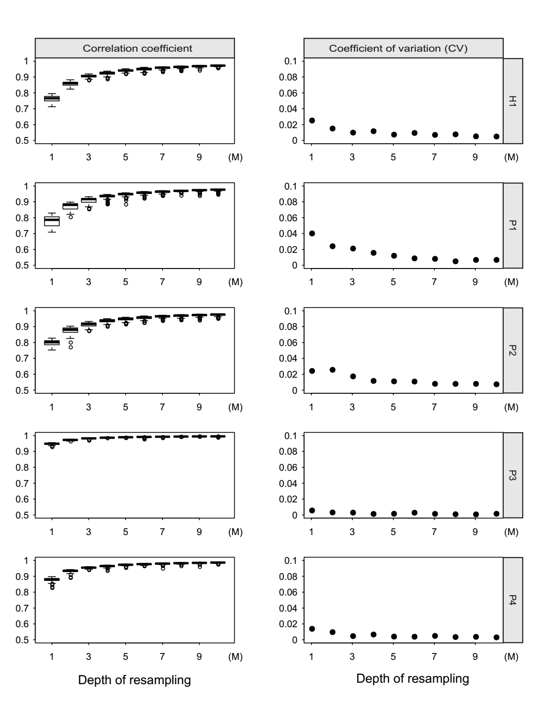

**Fig. 1. The efficiency of re-sampling sequencing depth for low pass WGBS.** Left of the figure showed the correlation coefficient between re-sampling low pass WGBS and total sequencing reads for 100 times from 1M to 10M. Right of the figure showed the coefficient of variation (CV) for 100 correlation coefficient between re-sampling low pass WGBS and total sequencing reads from 1M to 10M.

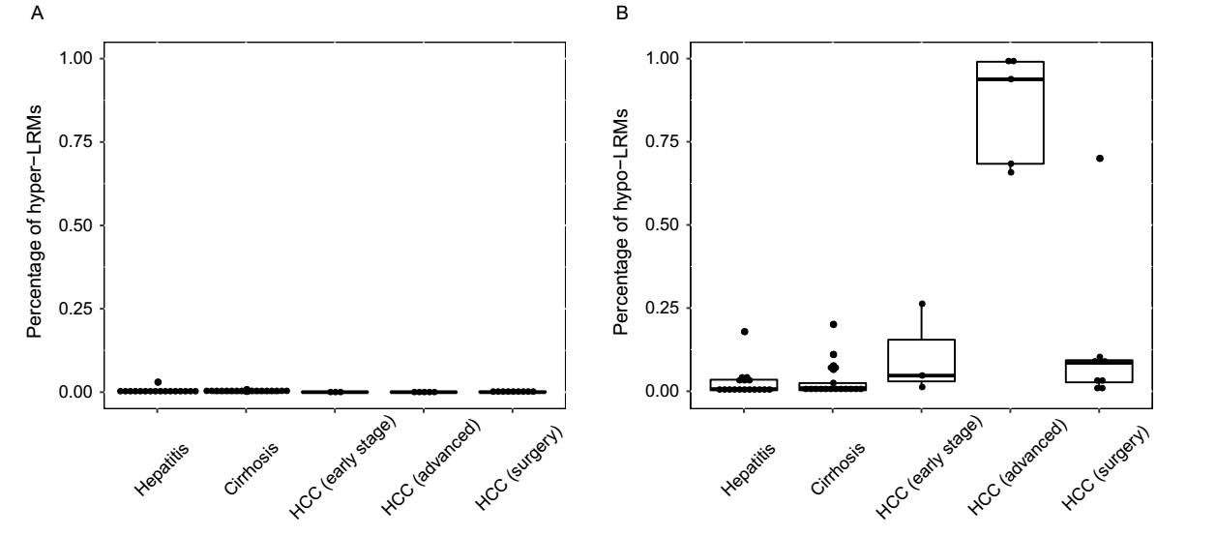

**Fig. 2 Whole genome-wide changed methylation of all the patients.** (A) The percentage of hyper-methylated long range regions (2-Mb) in chronic hepatitis, cirrhosis and HCC patients. (B) The percentage of hypo-methylated long range regions in chronic hepatitis, cirrhosis and HCC patients.

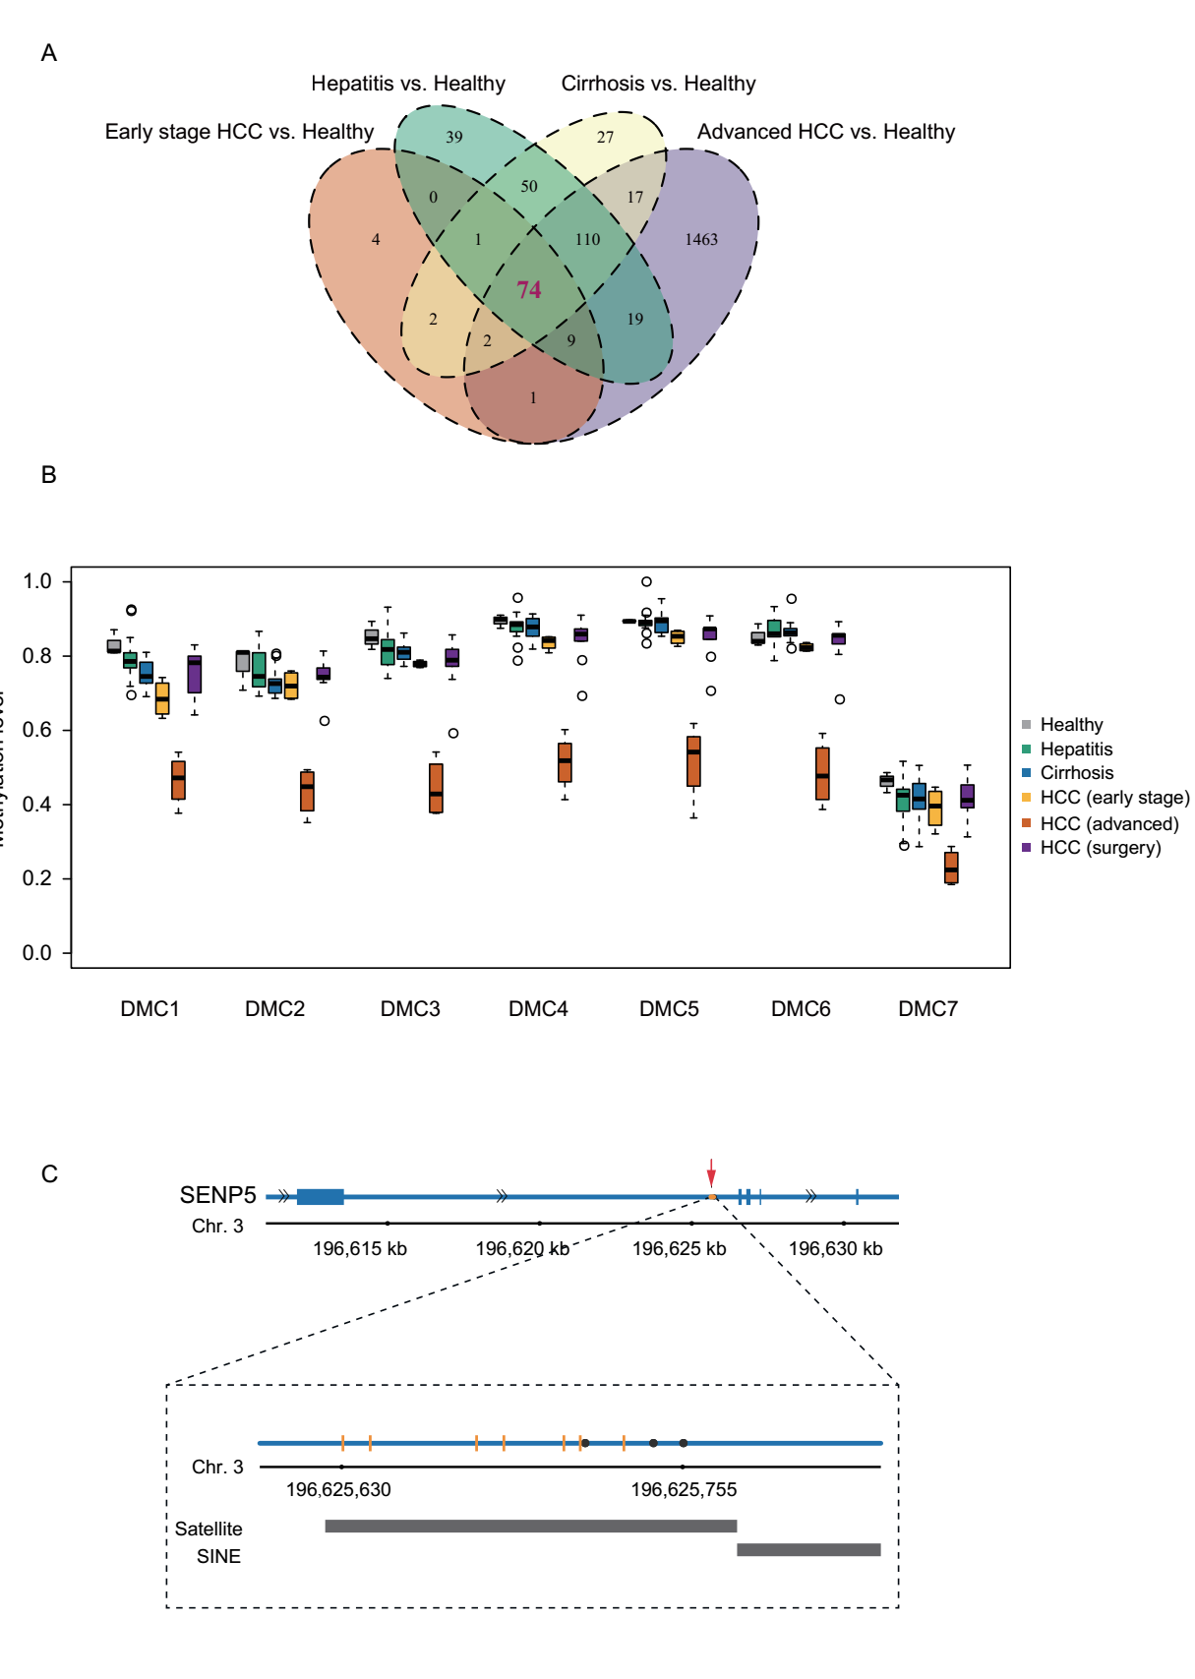

**Fig. 3. Differentially methylated CpGs (DMCs) identified in all the groups.** (A) Venn diagram showing the overlap of DMCs generated by 2 hypo-methylated chronic hepatitis patients, 1 hypo-methylated cirrhosis patient, 3 early stage HCC patients and 5 advanced HCC patients compared to healthy individuals. (B) Boxplot displays the methylation level of 7 DMCs of SENP5 in 3 healthy individuals, 17 chronic hepatitis, 17 cirrhosis, 3 early stage HCC, 5 advanced HCC and 9 HCC patients after surgery. (D) The locus of 7 DMCs and 3 reported HBV integration sites in intron 2 of SENP5. The black dots represent the HBV integration sites and the orange vertical lines represent the 7 DMCs. The black bar labels in the bottom of the figure represent the locus of repeat marker in this region.

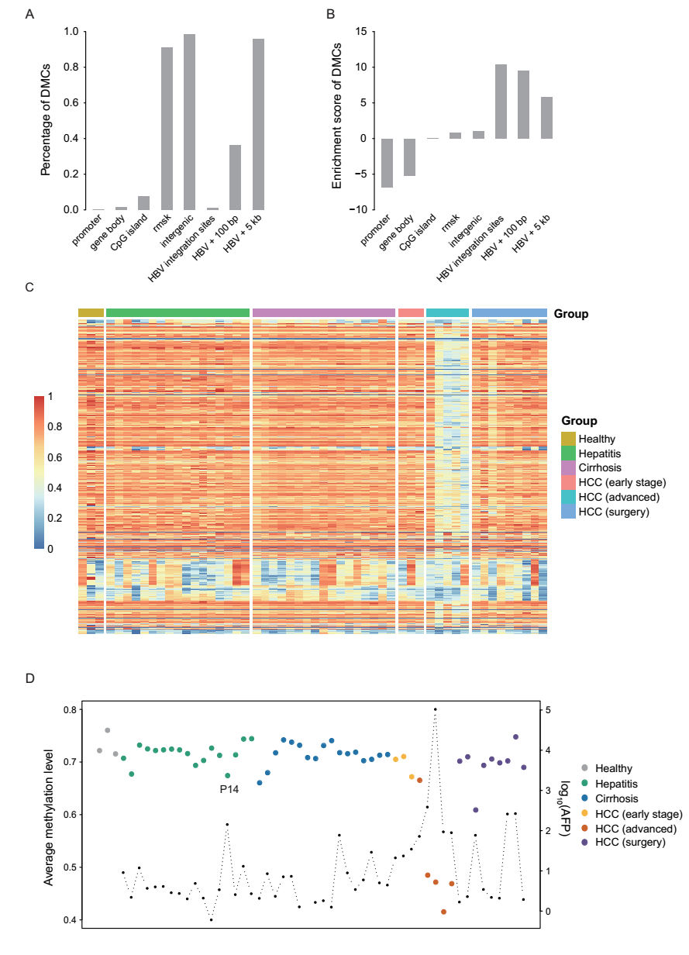

**Fig. 4. DMCs and CpGs are related to HBV integration sites.** (A) The percentage of DMCs located in different genomic elements and regions related to HBV integration sites. (B) The enrichment scores of DMCs in different genomic elements. (C) The heatmap display the methylation level of the CpGs located within 100 bp of the HBV integration sites in all the samples. (D) The average methylation level of all the CpGs located within 100bp of the HBV integration sites in all the samples. The black dot represents the AFP level.